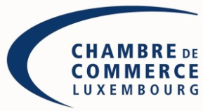

Kindly return the form
before April 2, 2014 to Luxembourg Chamber of Commerce
Mrs. Louise Akerblom & Violaine Mathurin
e-mail: international@cc.lu

Russian Region day: Nizhny Novgorod
Friday, 4th of April 2014

Registration Form

Company:

Address:

Phone: / Mobile:

E-mail: / Web-site: _

Name and Title of the participant(s):

Activity:

Will participate in the round table:

YES NO

Would like to present his company:

YES NO

Will participate in the networking-lunch:

YES NO

Date:____________________________________

Signature:________________________________

