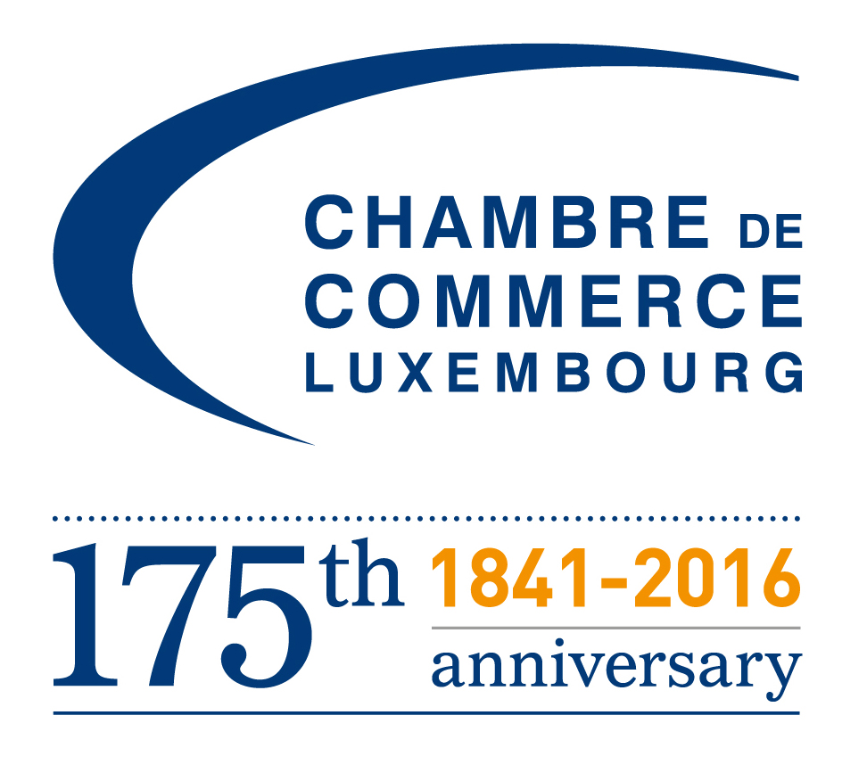

VISIT OF AN ICT DELEGATION FROM PORTUGAL
Draft Program (as of 19/05/2016)
Wednesday, 25th of May 2016
Venue: Luxembourg Chamber of Commerce
09:00 Arrival of the guests and registrations
09:25 Signature of the Golden Book
09:30 Welcome address
Jeannot Erpelding, Director, International Affairs, Luxembourg Chamber of Commerce
09:35 Opening remarks
HE Carlos Pereira Marques, Ambassador of the Republic of Portugal to Luxembourg
09:50 The Luxembourg economy in a nutshell
Jeannot Erpelding, Director, International Affairs, Luxembourg Chamber of Commerce
10:10 The Luxembourg ICT Sector
Grégory Saeul, Ministry of the Economy, ICT Department
10.25 The ICT sector in Portugal
Representative, Portuguese Association
10:55 Presentation of the Web Summit 2016, in Lisbon
Helena Malcata, AICEP Portugal Global
11:15 Presentation of the Portuguese companies
11:45 Presentation of the Luxembourg companies
12:00 Questions & Answers session
12:15 Networking Lunch in presence of Carlo Thelen, Director General, Luxembourg Chamber of Commerce
13:30-17.00 Btob meetings
19h00 Gala Anual da CCILL – Câmara de Comércio e Industria Luso-Luxemburguesa
Casino 2000
Rue Th. Flammang
5618 Mondorf-les-Bains

