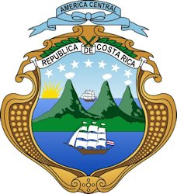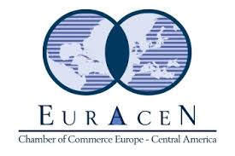
Round-Table on the occasion of the visit of HE Alexander Mora, Minister of Foreign Trade of Costa Rica:
“Business Opportunities between Central America and Luxembourg”
Draft program (as of 18/01/2017)
Monday, 6th of February 2017
Venue: Luxembourg Chamber of Commerce
14:00 Arrival of the guests
14:25 Signature of the Golden Book
14:30 Welcome address
Carlo Thelen, Director General, Luxembourg Chamber of Commerce (tbc)
14:40 Keynote speech about Costa Rica and Central America in general
HE Alexander Mora, Minister of Foreign Trade of Costa Rica
15:00 Presentation of Costa Rica and the Secretaría de Integración Económica Centroamericana (SIECA)
HE Istvan Alfaro, Ambassador of Costa Rica to the Kingdom of Belgium, the Grand Duchy of Luxembourg and the European Union
15:30 Opportunities in Central America and the activities of Euracen, the Chamber of Commerce between Europe and Central America
Erwin De Weerdt, President, Euracen
15.50 Testimonial of a Luxembourg company active in Costa Rica
16:00 Presentation of the Luxembourg companies and Round Table discussion
16:30 Networking drink

