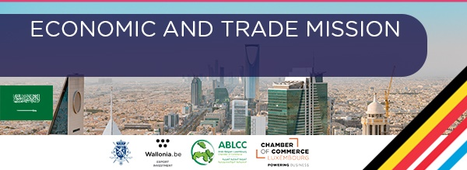

PROVISIONAL PROGRAMME BELGIUM-LUXEMBOURG JOINT MISSION

The program below is indicative and is still subject to changes. It will consist of group visits (usually by sector), networking events as well as individual B2B meetings.
Friday, March 11th - Luxembourg - Riyadh
10:50 Departure from LUXEMBOURG with KLM
22:30 Arrival in Riyadh and transfer to the Hotel Movenpick
Saturday, March 12th - Riyadh
Free Morning
16:00 – 16:15 Welcome event at the Belgian Residence + distribution of bags with the programs/goodies
16:15 – 16:35 Speech by the Ambassador of Belgium, AWEX, ABLCC and Luxembourg Chamber of Commerce
16:35 – 17:00 Presentation of the program and activities
17:00 – 17:30 Briefing: legal outlook of doing business in Saudi
17:30 – 18:00 Briefing: cultural aspects of doing business with Saudi Arabia
18:00 – 22:00 Walking dinner hosted by Embassy of Belgium – Networking between participants

Sunday, March 13th - Riyadh
Presence of the entire delegation at the Saudi Council of Chambers in presence of the Riyadh Chamber of Commerce
09:00 – 10:00 Arrival of the delegation and check-in
10:00 – 10:30 Welcome speech
10:30 – 12:30 Presentations of Saudi Economy - Presentation of Belgian Economy - Presentation of Luxembourg Economy + Q/A
12:30 – 14:00 Networking lunch
14:00 – 15:00 Press coverage + photos
15:00 – 16:00 Group visit to Business Incubators and Accelerators Company (BIAC) + presentation of the soft-landing program
16:00 – 17:00 Presentation of Neom + Q/A
17:00 Return to the hotel
19:00 – 22:00 B2B networking dinner at Al Nakhla Resort

Monday, March 14th - Riyadh
09:00 – 15:00

Health | Environment & Energy | Entertainment | Food | Construction | Transport & Logistics
Group Visit | Group Visit | Group Visit | Group Visit | Group Visit | Group Visit
Lunch | Lunch | Lunch | Lunch | Lunch | Lunch
Individual B2B’s | Individual B2B’s | Individual B2B’s | Individual B2B’s | Individual B2B’s | Individual B2B’s

15:30 Meeting at the hotel for departure to Red Sea Project
16:00 – 17:00 Visit of Red Sea Project
18:00 – 19:00 Visit of the town of Diriyah
19:00 Free time

Tuesday, March 15th - Riyadh/Jeddah
09:00 – 15:00

Health | Environment & Energy | Entertainment | Food | Construction | Transport & Logistics
Group Visit | Group Visit | Group Visit | Group Visit | Group Visit | Group Visit
Lunch | Lunch | Lunch | Lunch | Lunch | Lunch
Individual B2B’s | Individual B2B’s | Individual B2B’s | Individual B2B’s | Individual B2B’s | Individual B2B’s

15:30 Transfer from hotel to airport
17:00 – 18:40 Flight SAUDIA SV1041 from Riyadh to Jeddah
20:00 – 20:30 check-in at the Hotel Galleria
21:00 – 23:00 Reception organized by Mr. Hassan KABBANI, Honorary Consul of Belgium to Jeddah

Wednesday, March 16 – Jeddah/Dammam
Entire group
10:00 Transfer to Jeddah Chamber of Commerce
10:30 – 11:30 Meeting at the Chamber of Commerce + presentations
12:00 – 16:00

Health | Environment & Energy | Entertainment | Food | Construction | Transport & Logistics
Group Visit | Group Visit | Group Visit | Group Visit | Group Visit | Group Visit
Lunch | Lunch | Lunch | Lunch | Lunch | Lunch
Individual B2B’s | Individual B2B’s | Individual B2B’s | Individual B2B’s | Individual B2B’s | Individual B2B’s

16:00 Transfer from the hotel to the airport
19:00 – 20:55 Flight SAUDIA SV 1124 from Jeddah to Dammam
21:30 Check-in at the Hotel Sofitel

Thursday March 17th - Dammam
Entire group
10:00 Meeting at the Chamber of Commerce of Asharqia
11:00 – 13:00 B2B’s and networking lunch
13:00 – 17:00

Health | Environment & Energy | Entertainment | Food | Construction | Transport & Logistics
Group Visit | Group Visit | Group Visit | Group Visit | Group Visit | Group Visit
Lunch | Lunch | Lunch | Lunch | Lunch | Lunch
Individual B2B’s | Individual B2B’s | Individual B2B’s | Individual B2B’s | Individual B2B’s | Individual B2B’s

17:00 – 18:30 Group visit
18:30 – 19:30 Rest at the hotel
20:00 – 22:00 Closing dinner
23:30 Departure from the hotel to the airport

Friday, March 18 Dammam - Luxembourg
02:40 Flight from Dammam to Luxembourg
10:20 Arrival in Luxembourg

ACCOMODATION, TRANSPORTS AND FORMALITIES
We offer participants a very competitively priced package including flight and hotel as well as transfers from the airport to the hotel. For internal flights, each participant will have to take care of his reservation directly via the airline's website. More information will follow. For organizational facilities, we encourage members to take advantage of this package. We will not be able to ensure the various transfers for companies taking their flight on other dates or choosing other hotels. In addition, all departures from the delegation to the appointments will be from the hotels we have chosen.
We would also like to mention that companies should not be afraid of sending female delegates and that on the contrary, it could be an asset in meetings with local actors!

Hotels:
We have rooms in the following hotels:
Riyadh:
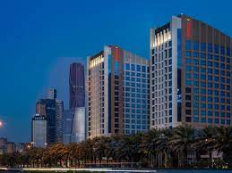

Hotel Movenpick – Single Superior Room inc. breakfast – +/- 200 € / night TTC (725 SAR + 15% VAT + 5% Municipal tax);
Site web : https://all.accor.com/hotel/B4X1/index.fr.shtml

Jeddah:

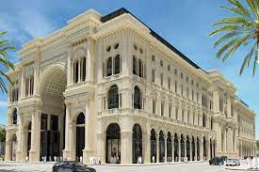

Hotel Galleria – Deluxe Single Room inc. breakfast – +/- 180 € / night TTC (725 SAR + 15% VAT + 5% Municipal tax);

Website: https://www.thehotelgalleria.com/

Dammam:

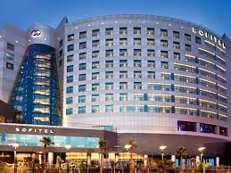

Hotel Sofitel - Superior Room city view or Luxury room Sea view inc. Breakfast – 155 € / night TTC or 185 € / night TTC (550 SAR or 650 SAR + 15% VAT + 5% Municipal tax);
Website: https://all.accor.com/hotel/5988/index.fr.shtml

In total, the trip including flights + hotel nights in the three cities amounts to about € 2210 / person

Flights :
Luxembourg (LUX) – Riyadh (RUH) - 11th March 2022
10:50 Luxembourg - 22:30 Riyadh, King Khalid International Airport (stop in Amsterdam)
Riyadh (RUH) – Jeddah (JED) – 15th March 2022
17:00, Riyadh, King Khalid International Airport - 18:40 Jeddah, King Abdulaziz International Airport
Flight duration:1 h 40
Jeddah (JED) – Dammam (DMM) – 16th March 2022
19:00 Jeddah, King Abdulaziz International Airport - 20:55 Dammam, King Fahd International Airport
Flight duration: 1 h 55
Dammam (DMM) – Luxembourg (LUX) – 18 mars 2022
02h40 Dammam, King Fahd International Airport - 10h20 Luxembourg (stop in Amsterdam)

Formalities related to health rules:
From February 1st 2022, it will be mandatory to have obtained a booster of one of the vaccines approved in Saudi Arabia to enter the territory.
These vaccines are:
- Pfizer or Moderna (3 doses in total)
- Astrazeneca (3 doses in total)
- Johnson & Johnson (2 doses in total)
In addition, wearing a mask is also mandatory (preferably FFP2 masks) indoors and outdoors as well as social distancing rules and any measures to limit the spread of the virus. Since the rules are likely to change between now and the mission, new information on the health rules will be communicated to you before your departure.
Further information can be found on: https://www.visitsaudi.com/en/covid-19-information-page

