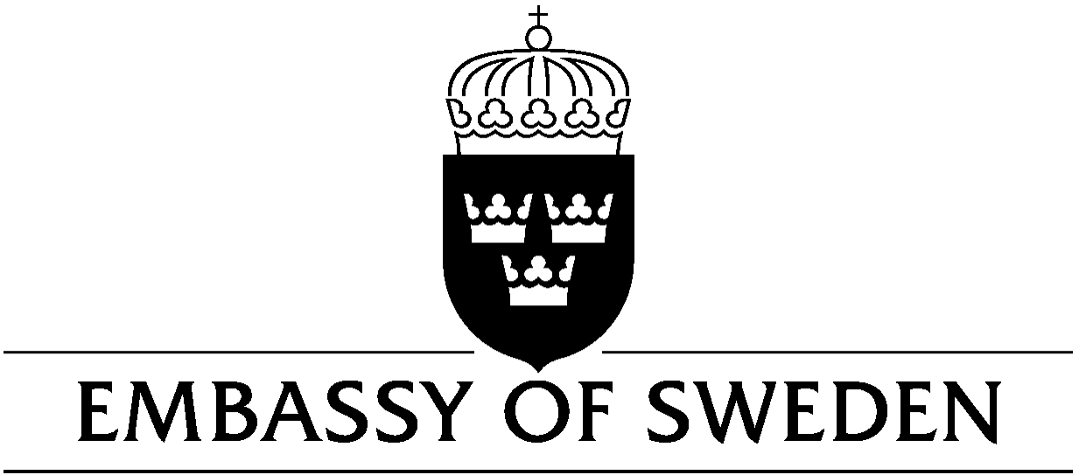

Breakfast Seminar
“TTIP – the Swedish perspective”

Thursday, February 12, 2015

Luxembourg Chamber of Commerce
7, rue Alcide de Gasperi – L-1615 Luxembourg
Luxemburg p.t. Stockholm

08h30 Registration

09h00 Welcome Address by Mr. Carlo THELEN, Director General, Luxembourg Chamber of Commerce

09h05 Opening remarks by HEMrs. Maria Christina LUNDQVIST, Ambassador of Sweden to Luxembourg

09h10 Keynote speech “TTIP: Europe in the new world order” by HEMr. Jonas HAFSTRÖM, Ambassador and Senior Adviser for Trade Promotion, Ministry for Foreign Affairs, Sweden

09h40 Presentations “TTIP – Where do we stand?” and “The view of business” by Mr. Dirk VANTYGHEM, Director of International Affairs and by Mr. Dominic BOUCSEIN, Trade Advisor, International Affairs from EUROCHAMBRES

10h00 Q&A Session

10h30 End of the seminar

