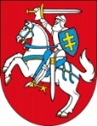
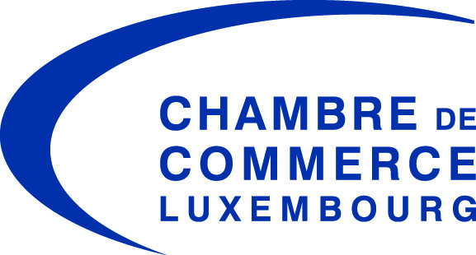

Embassy of Lithuania in Belgium
and to the Grand Duchy of Luxembourg

Country Seminar: Lithuania

Tuesday, September 29, 2015

Luxembourg Chamber of Commerce
7, rue Alcide de Gasperi – L-1615 Luxembourg

Programme and Delegation

Programme:

4:00 pm Registration
4:30 pm Welcome Address Jeannot Erpelding, Director International Affairs of the Luxembourg Chamber of Commerce
4:35 pm Opening Remarks
H.E. Gediminas Varvuolis, Ambassador of Lithuania to Luxembourg

4:40 pm Opening Speech
Simonas Šatūnas, External Economic Relations Department Director, Ministry of Foreign Affairs Lithuania

4:45 pm Business opportunities in Lithuania
Mantas Katinas, Managing director of Invest Lithuania

5:00 pm The role of the banking sector in a new economic and regulatory environment
Stasys Kropas, President of Association of Lithuanian Banks

5:15 pm Lithuanian and Baltic venture capital ecosystem – from zero to hero
Šarūnas Šiugžda, Board Member and Co-founder of the Lithuanian Private Equity and Venture Capital Association

5:30 pm Luxembourg, a leading international financial centre
Tom Theobald, Deputy Director, Luxembourg for Finance

5:45 pm Testimonial on the investment and business climate in Lithuania
Pierre Girault

5:55 pm Q&A

Networking Reception

Lithuanian delegation:

Mr. Stasys Kropas President of Association of Lithuanian Banks
Mr. Mantas Katinas Managing Director of Invest Lithuania
Mr. Gintautas Galvanauskas General Director of Danske bank
Mr. Gediminas Varvuolis Ambassador of Lithuania to Luxembourg
Mr. Šarūnas Šiugžda President of Lithuanian Private Equity and Venture Capital Association
Mr. Simonas Šatūnas External Economic Relations Department Director, Ministry of Foreign Affairs
Mr. Sigitas Mitkus Director of Financial Market Policy Department, Ministry of Finance
Mrs. Liliana Jaroslavska Second Secretary, Embassy of Lithuania
Mrs. Eglė Jacevičiūtė Attaché, Embassy of Lithuania

