AFFINITY S.A.
AV. ANTÓNIO AUGUSTO AGUIAR N.130
1050-020 LISBOA
PORTUGAL

Mr. CARLOS CORREIA
CEO
E-mail: carlos.correia@affinity.pt
www.affinity.pt

Born in September 2012, AFFINITY currently employs more than 160 collaborators, mainly IT and Telecommunications engineers, with projects in more than ten different countries.
AFFINITY is a generalist technological company, focused in the satisfaction of the client, and the satisfaction of its technical team.

AFFINITY BASES ITS ACTIVITIES IN THREE MAJOR DISTINCTIVE FIELDS

OUTSOURCING IT AND TELCO
Since the very beginning, Affinity has always invested in Outsourcing Services, engaging its technical consultants with the Clients that need highly competent professionals to address the complexity of projects in the IT & Telecommunications areas.

NEARSHORING
Affinity relies on a strong foundation developing projects for overseas companies. Its headquarters are located in Lisbon, Portugal, a country with privileged conditions for providing nearshoring services.

SOFTWARE MOBILE
Affinity develops all kinds of applications, taking advantage of most recent mobile devices that enable the mobility workplace. Furthermore, it leverages the most recent technologies to make any website or internal application compatible with the most widely used devices.

TECHNICAL AREAS

DEVELOPMENT

SYSTEMS

BUSINESS INTELIGENCE

TELECOMUNICATIONS

PERFORMETRIC
ANYBRAIN, S.A (“PERFORMETRIC)
PRAÇA CONDE AGROLONGO N.123
4700-312 BRAGA
PORTUGAL

MR. ANDRÉ PIMENTA RIBEIRO
CEO
E-mail: apimenta@performetric.net
www.performetric.net

Incorporated in August 2015, Performetric is an IT-based startup company, focused on improving work life balance, reducing absenteeism and stress related illnesses through a better performance management system, applied not only to standard tasks but also to critical systems monitoring and decision making support systems.

Performetric has developed a brain machine interface software tool for non-invasive real time monitoring of mental fatigue (Performetric). This set of innovative software products relies on a machine learning algorithm based in several variables acquired from the user’s interaction pattern with input devices (keyboard, mouse, trackpad). This interaction pattern will be specific to the task performed and can thus be adapted to each user and their user requirements. Performetric allows tracking the accuracy, speed and ultimately the performance of electronic device users, while providing recommendations for better workforce management, increasing worker retention and productivity, in an HR Corporate Responsibility perspective, but can be also very useful in military, call center and 24/7 operations.

Performetric stands out from the existing solutions on the market for its innovation because it allows a real-time fatigue detection, a non-invasive way, which so far only occurs in solutions for driving scenarios. Also, it is a solution for work environments and enables more effective management of human resources of any company, contrary to the traditional systems unable to adapt to different profiles.

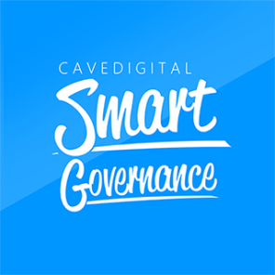
CAVEDIGITAL, Lda
CONVENTO S. MIGUEL DAS GAEIRAS
2510-718 GAEIRAS – ÓBIDOS
PORTUGAL

MR. JOÃO COSTA
BUSINESS DEVELOPER
E-mail: jcosta@cavedigital.com
www.smartgovernance.pt

CAVEDIGITAL is a software house, founded in the year 2000.
CAVEDIGITAL Smart Governance is a product that aids Organizations and Conglomerates to render their decision making processes paperless and agile in one single solution.
SUPPORT CONGLOMERATE DECISION-MAKING ECOSYSTEMS - Leverage on powerful collaboration and team work for agile multiple hierarchies, committees and boards, across the different Organizations part of the Conglomerate.

PROPOSAL AUTHORING AND COLLABORATION FEATURES

HIERARCHICAL DECISION-MAKING WORKFLOW PROCESSES

GAMIFICATION FEATURES

BOARD MANAGEMENT FEATURES

BOARD MEETING MANAGEMENT FEATURES

VOTING, DELIBERATION AND DECISION PROCESSES WHILE IN BOARD MEETING

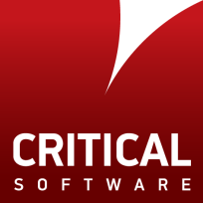

CRITICAL SOFTWARE, S.A. PARQUE INDUSTRIAL DE TAVEIRO, LOTE 49
3045-504 COIMBRA
PORTUGAL

MR.PAULO GUEDES
BUSINESS DEVELOPMENT DIRECTOR
E-mail: pguedes@criticalsoftware.com
www.criticalsoftware.com

CRITICAL Software provides systems, software and data engineering services for safety, mission and business-critical applications. Critical helps to ensure that clients meet the most demanding quality standards for software safety, performance and reliability. The company’s data engineering products and services also provide clients with the information they need to manage their important assets, helping them to achieve better business performances.
SECTORS AND SERVICES
Aerospace | Asset Management ; Embedded Software Development ; Internet of Things ; Operations and Logistics Support ; Safety Management ;Safety Training ;Systems Engineering
Automotive | Embedded Software Development; Internet of Things; Safety Management; Safety Training
Defence and Security | Asset Management ; Bespoke Solutions ; Embedded Software Development ; Internet of Things ; Maritime Solutions ; Operations and Logistics Support ; Safety Management ; Security ; Systems Engineering
Energy and Utilities | Asset Management ; Bespoke Solutions ; IoT and Smart Technology Services ; Managed Services ; Operations and Logistics Support ; Safety Training
Financial Services | Bespoke Solutions ; Branch Solutions ; Managed Services ; Security
Government | Bespoke Solutions; Emergency Management; Managed Services; Security; Voters Registration and Elections
Healthcare | Bespoke Solutions; Electronic Health Management Information; Internet of Things; Safety Management ; Safety Training
Railway | Asset Management; Embedded Software Development; Internet of Things; Safety Management; Safety Training.
Space | Bespoke Solutions; Embedded Software Development; Safety Management; Safety Training
Telecommunications | Bespoke Solutions; Internet of Things; Managed Services; Security; Telecom Operations; Support Systems.
Other Industries | Asset Management; Bespoke Solutions; Managed Services; Safety Management; Security.
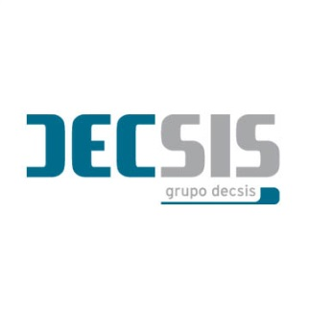

DECSIS – SISTEMAS DE INFORMAÇÃO SA
R. CIRCULARA NORTE, PARQUE INDUSTRIAL E TECNOLÓGICO DE ÉVORA, L2
7005-841 ÉVORA
PORTUGAL

MR. ARTUR ROMÃO
DIRECTOR, INNOVATION AND DEVELOPMENT
E-mail: artur.romao@decsis.pt
www.decsis.eu

DECSIS is a Portuguese company, founded in 1994, specialised in providing ICT services, currently being an authorized service provider for several manufacturers, offering services in multivendor and multi-brand environment.

DECSIS has invested in a secure, ISO 27001- certified data centre in Évora, in the south of Portugal, providing services to large customers. With this investment, the company has initiated a strategy of diversification and innovation of its service offering. This strategy also includes a policy based on promoting a culture of applied innovation, a strong focus on R&D in cooperation with academia, favouring the development of innovative products and processes.

The company intends to position itself properly in emerging technological areas, namely cognitive computing applied to the social economy, Internet of Things, big data analytics and smart cities.

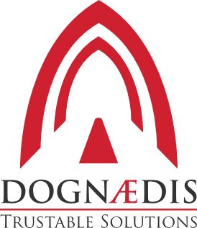
DOGNAEDIS
EDIFÍCIO C, RUA PEDRO NUNES
3030-199 COIMBRA
PORTUGAL

MR. FRANCISCO NINA RENTE
CEO
E-mail: frente@dognaedis.com
www.dognaedis.com

Dognædis was created by a team of researchers from CERT-IPN and University of Coimbra, focused on information security. After five years of activity, and due to the increasing success and positive feedback from several private and government organizations, DOGNÆDIS started as a private company. To reach such endeavor Dognaedis shall be devoted to bringing information security to organizations and individuals, through excellence in innovative solutions. Dognaedis promotes among all its collaborators a responsible freedom allied to a passion for knowledge. This respect for people is leveraged by continuous improvement supported and leading to state-of-art technologies.

SERVICE AREAS

ECONOMICAL SECTORS

Financial

Telco. & IT

Government

Defense

TECHNICAL SERVICES

Software Assurance

Business Continuity Support

Security Audit and Consultancy

Network Design and Management
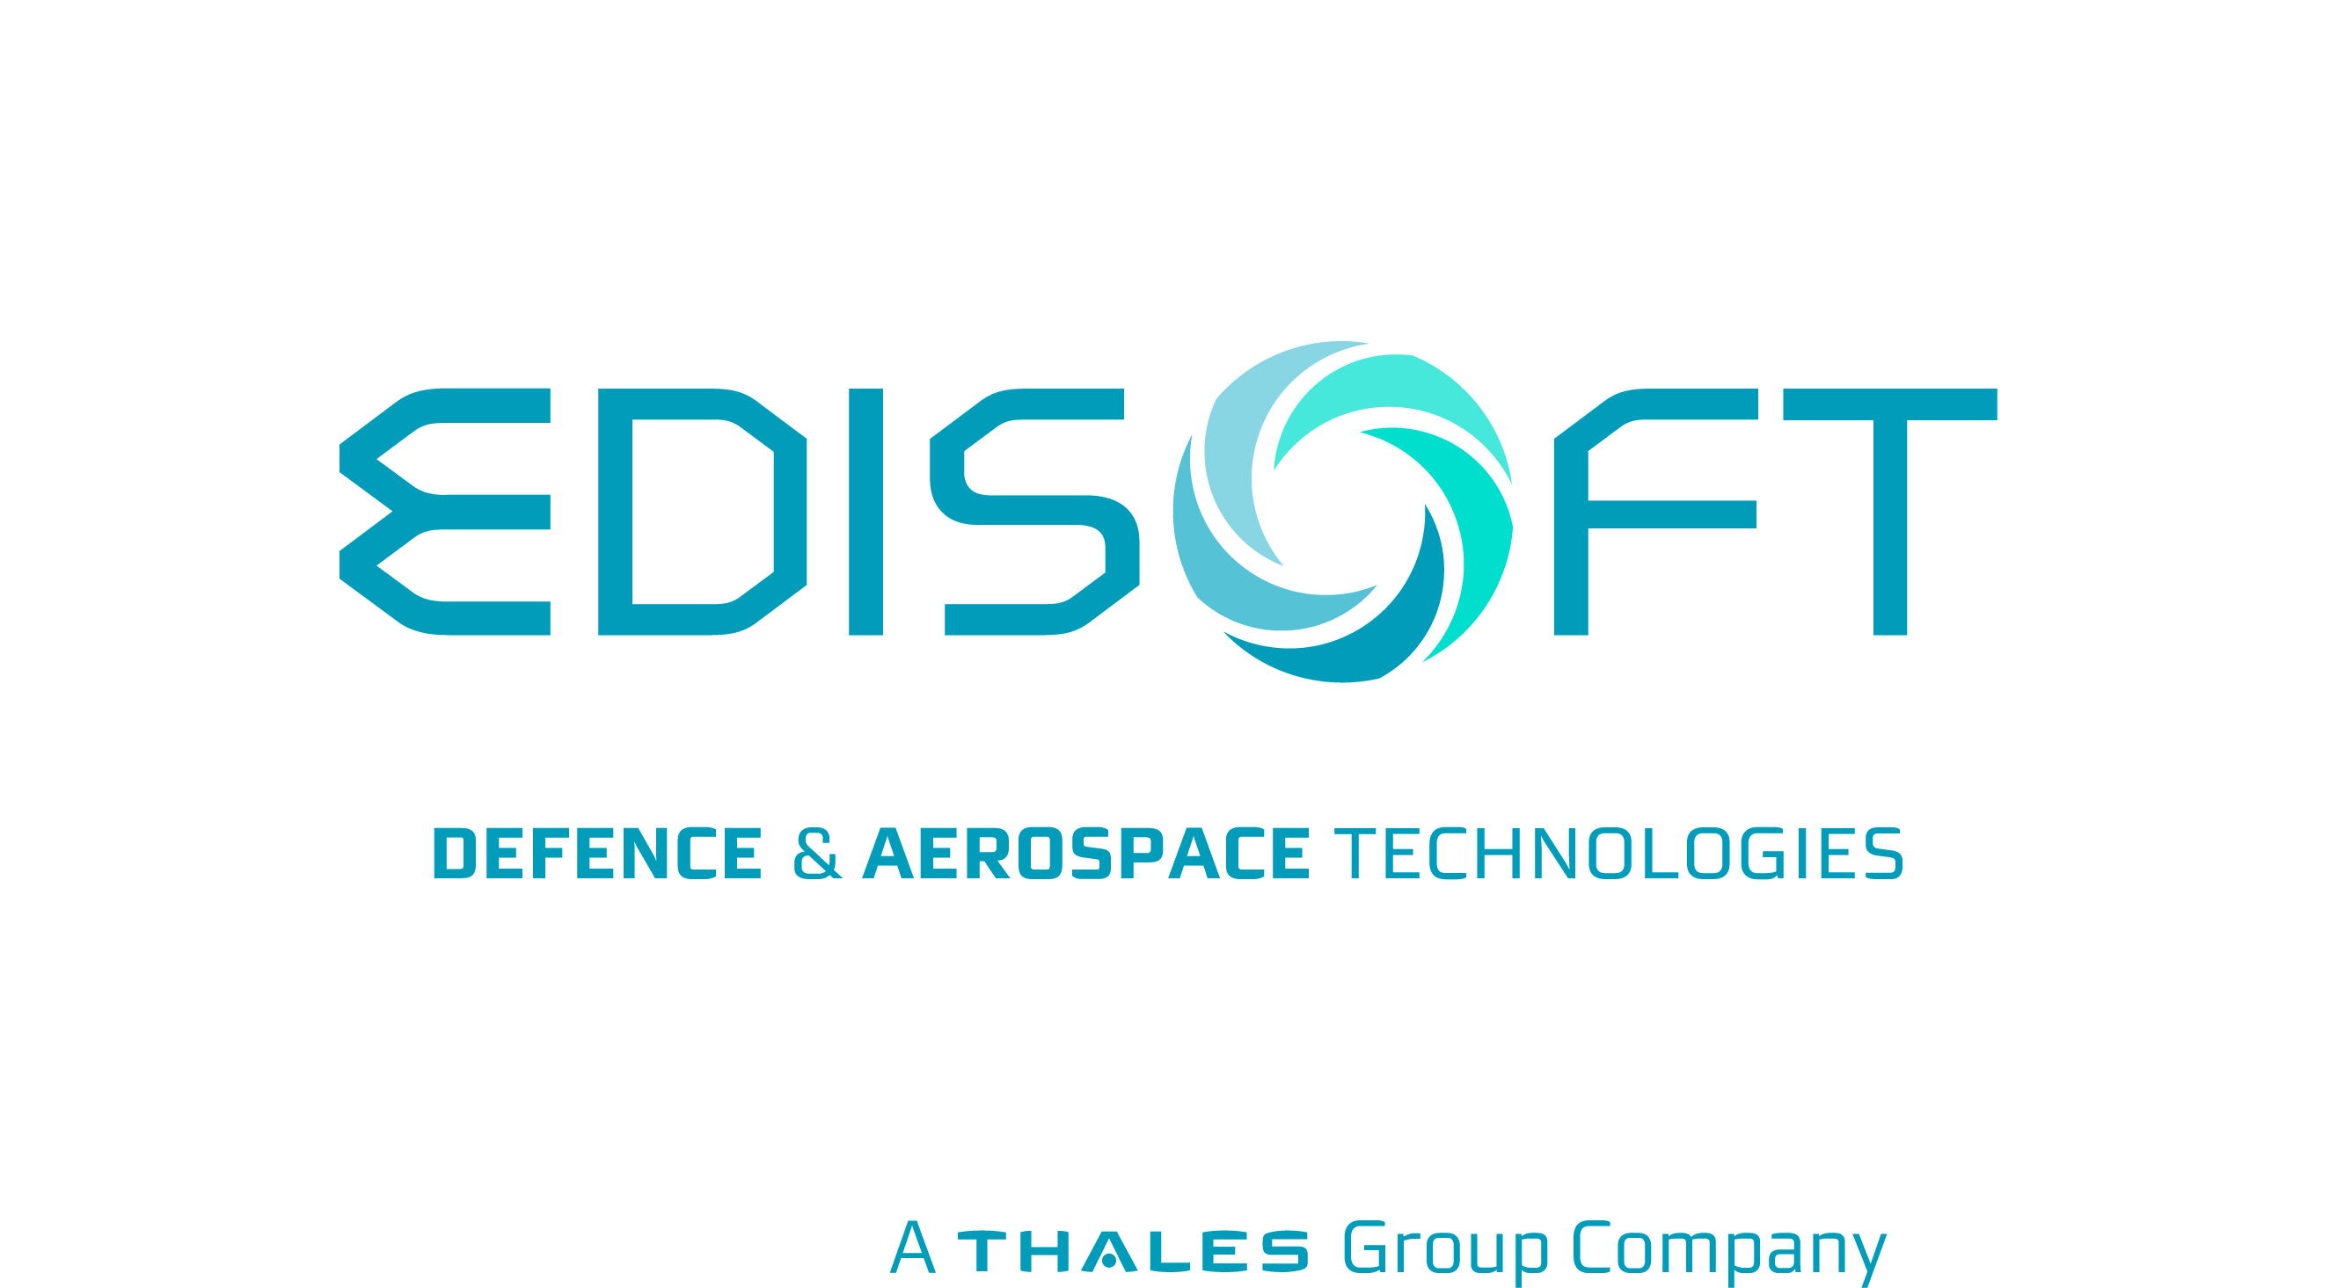
EDISOFT - A THALES GROUP COMPANY
RUA CALVET MAGALHÃES
2770-153 LISBOA
PORTUGAL

MR. FERNANDO BRAZ DE OLIVEIRA
COMMERCIAL DEPARTMENT
E-mail: fernando.oliveira@edisoft.pt
www.edisoft.pt

EDISOFT is a joint venture between Thales, NAV Portugal and Empordef holding, which promotes and delivers innovative solutions that enhance its customer’s critical systems´ security, on land, sea, air, space and cyberspace, through a technical team of excellence

Building on more than 25 years of experience, EDISOFT provides military and security solutions for a wide range of national and international customers. The company has taken part in various Portuguese Navy modernization programmes, providing operational support for combat systems, radars and simulation systems as well as advanced integrated logistic support and configuration management systems for naval vessels.
DEFENCE & SECURITY SYSTEMS | AERONAUTICS & SPACE SYSTEMS
Able to offer engineering solutions, consulting and integration services with high complex technology, EDISOFT has an extensive experience in the development and implementation of critical programs and projects in the Defence and Security Markets.  Aware of today's information technology demands, EDISOFT exhibits in fact a profound understanding and know-how of defence and security specifications, needs, activities and quality standards, having delivered a number of technologically advanced solutions for C4I systems to customers around the world. | EDISOFT offers advanced software solutions and highly qualified IT consulting services for the Aeronautics and Space Industries. EDISOFT has a broad experience and has built a solid reputation in the Aerospace market due to its participation in the development of Space-Based Infrastructures like the Land Surface Analysis SAF, Galileo and the European Data Relay System, along with development of solutions and services in the areas of Meteorology, Earth Observation, On-Board Software, Airport Operations and Air Traffic Management.  EDISOFT is responsible for the management of Santa Maria Ground Station, in Azores, which is able to receive telemetry and earth observation data from launchers and satellites.

FINDMORE CONSULTING
AV. D. JOÃO II, LOTE 42, ESCRITÓRIO 602
1990-095 LISBOA
PORTUGAL

MR. RUI MACHADO
CEO
E-mail: rui.machado@findmore.eu
www.findmore.eu

Findmore Consulting, S.A. is specialized in Information Technologies contributing to major projects in Portugal and Europe since 2008. Findmore projects are challenging and its team ambitious, dedicated and specialized. Being a part of Findmore also means having access to training at Findmore Academy, Research & Development at Findmore Labs and working with the largest Portuguese and European companies. Findmore focus is on highly specialized IT outsourcing and nearshore development.
PRODUCTS
Digital Business Platform

Business & IT Transformation

Analytics & Decisions

Process

Integration

In-Memory Data

Transaction Processing

Software AG Cloud

FOCUS2COMPLY
RUA PEDRO E INÊS, 2.22 – SALA D
1990-075 LISBOA
PORTUGAL

MR. LUÍS LOBO E SILVA
PARTNER
E-mail: luis.silva@focus2comply.pt
www.focus2comply.pt

Focus2Comply is a Portuguese share owned company, founded in January 2015, resulting from the consolidation of procedural and technological skills and application of good practices in the management of information Confidentiality, Integrity and Availability.

Focus2Comply wants to help you select benchmarks of excellence and incorporate them within your organization, identifying the internal and external aspects, the business requirements and expectations, and with a risk management supported approach, identify benchmarks and respective practices that really adds value to the organization as a whole and promote continuous improvement.

MANAGEMENT SYSTEMS

IT SECURITY

NETWORK INFRASTRUCTURE

Risk and Privacy Management, Personal Data Management and Information Security, Business Continuity and IT infrastructures Availability, are some of the issues for which Focus2Comply has unsurpassed knowledge, available as an Audit, Consulting and Training services matrix.
Focus2Comply is ACP (Associate Consultant Program) of BSI (British Standards Institute) for Business Continuity and Information Security Management.

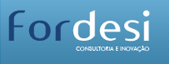
FORDESI SA
RUA IRENE LISBOA, 48, CAVE ESQ.
2630-246 ARRUDA DOS VINHOS
PORTUGAL

MR. PEDRO CORTEZ
DIRECTOR
E-mail: pedro.cortez@fordesi.pt

FORDESI is a reference company in different areas of consulting, with an important position in the management consulting market, both at national and European levels. The company has successfully evolved over the years, not settling and always investing in a differentiation strategy of its services. A constant monitoring of the market and openness to the world allows a proactive attitude and ability to adapt to any economic or technological change.
The strong strategic alliances established with European level partners, with activities in the areas of innovation and technological development, also constitute a major competitive factor of FORDESI.

SECTORS

LOGISTICS AND TRANSPORTS
Fordesi presents a unique skills base, experience and technology in this sector in Portugal.
CENTRAL AND LOCAL ADMINISTRATION
Services and Solutions for Public Administration, Autarchies and regional and local entities.
MARITIME PORT SECTOR
Fordesi presents itself as a reference company, having developed some of the most relevant structural projects in this sector.
INDUSTRY AND SERVICES
Business services for industry and services.

SOLUTIONS

BUSINESS INTELLIGENCE
Structure an efficient, agile and integrated organization, based on information and knowledge management.
PROJECT DEVELOPMENT
Software Development with Productivity, Quality and Effectiveness.
FORGEST ERP
FORgest is an integrated management system oriented towards small and medium enterprises in all sectors of economic activity.

GLINTT
BELOURA OFFICE PARK, EDIFÍCIO 10, QUINTA DA BELOURA
2710-693 SINTRA
PORTUGAL

MR. CRISTÓVÃO CARVALHO
COUNTRY MANAGER BENELUX
E-mail: cristovao.carvalho@glintt.com
www.glintt.com

Glintt – Global Intelligent Technologies is one of the biggest Portuguese technological companies and is listed on Euronext Lisbon. It operates in Europe, Africa and Latin America and in its expansion strategy in the International Market, Glintt created Glintt España (Spain), Glintt Poland and more recently, Glintt Brazil. It's also strongly present in Germany, United Kingdom, France and Holland.
Glintt has lots of experience in developing IT solutions for Hospitals and Healthcare related institutions for electronic medical records, patient’s portals, bed management and therapies, among others.

SECTORS
Banking | Telecommunications | Health | Trade | Industry | Public Administration

PRODUCTS
Glintt Farma | Organizes its business regarding the continuous improvement of pharmacies. It operates in the following areas: Architecture; Conception; Pharmacy Expo; Pharma TV; Robotics; Software; Equipment and Training. In addition, all types of refurbishments, maintenance and support are given by this business unit.
Glintt Consulting | Provides IT consulting services at all levels and sectors. With a wide offer of technical consultant services, implementation of ERP's, integration of systems, development of customized applications, staffing, applicational outsourcing, outsourcing of infrastructures and outsourcing of business processes

GMV
AV. D. JOÃO II, 43, TORRE FERNÃO DE MAGALHÃES, 7º
1998-025 LISBOA
PORTUGAL

MR. JOSÉ NEVES
DIRECTOR
E-mail: jose.neves@gmv.com
www.gmv.com

GMV’s goal is to support its client's processes by dint of technologically advanced solutions, providing integrated systems, specialized products and services covering the whole life cycle. These range from consultancy and engineering services up to the development of software and hardware, the integration of turnkey systems and operational backup.
GMV is a privately owned technological business group with an international presence. Founded in 1984, GMV offers its solutions, services and products in very diverse sectors.
SECTORS
Aeronautics
Banking and insurance
Business ICT
Cybersecurity
Defense and Security
Healthcare
Public Administration
Space
Telecommunications
Transportation
INFINITE BUSINESS SOLUTIONS
AV. AFONSO COSTA 12, S/L
1900-035 LISBOA
PORTUGAL

MR. PAULO MENDONÇA DIAS
EXECUTIVE DIRECTOR
E-mail: pdias@infinite.pt
www.infinite.pt

Infinite Business Solutions is a software development company based in Lisbon and is an authorized education reseller for Microsoft.

Products

Faceware – Application cover, connectivity optimization and complementing operations

Inquiry Manager – Survey inquiries, online software that fills, collects, monitors and analyses data in real time

Solutions

Education | Parking | Logistics |Application Management

Connections Management | Survey Management | Access Control

SERVICES

ERP Development | IT Security | Digital Marketing | IT Consulting
Optimise decisions, remove redundancies, reduce timings. To support and integrate every area of your business. Flexible and custom-built services. | Analysis, auditing, certifications or security systems assembly, conceived for each situation, fighting cyber attacks and protecting critical data. | Website design, social networks management and strategies planning to boost your online presence, to strengthen your brand and deliver results. | All technological needs of your company are covered – hardware, software, network management or more specific IT solutions.

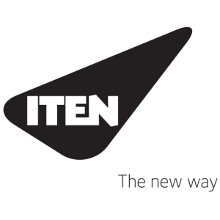

ITEN SOLUTIONS S.A.
RUA COSTA CABRAL, 575
4200-223 PORTO
PORTUGAL

MR. DUARTE VAZ
NEARSHORE MANAGER
E-mail: duarte.vaz@iten.pt
www.iten.pt

ITEN SOLUTIONS is the result of combined strengths of Prológica and CPCis, two of the largest and more representative Portuguese companies of the ICT sector, in order to create specific, joint corporate offer, to better address the European market’s needs. As a result, ITEN has a reinforced performance capacity which benefited from the complementary offer of both organizations, which hold a long history of market credibility and quality, creating one of the biggest companies and essential benchmark of the ICT sector in Portugal, with a sophisticated and complete range of services and skills at its client’s disposal.

ITEN operates in Europe, Middle East, North and South America and Africa.

SERVICES
Consulting and Auditing | - Implementation of management systems  - Audits and compliance checks
Support and Maintenance | - Warranty extension contracts and support  - Bank of hours with flexible management and usage
Training and Certification | - Specialised and certified training  - Authorised certifying center
IT Skills | - Human Capital Management  - Specialised resources
Licensing | - Contract management  - Support and Counseling
Repair Center | - Multi-brand repair center  - Logistics management
ServiceDesk | - Service management  - Helpdesk and technical support
Aplicational Development | - Collaborative Portals  - Aplicational consulting and integration

LINKARE TI – TECNOLOGIAS DE INFORMAÇÃO LDA
AV. 5 DE OUTUBRO 77, 1º ESQ.
1000-138 LISBOA
PORTUGAL

MR. PAULO RIBEIRO
CEO
E-mail: pribeiro@linkare.com
www.linkare.com

Linkare is an IT company specialized in the provision of Java services and solutions for both private and public sector. Java Excellence is its motto and driver towards the development of a professional and trustworthy relationship with its customers. Since 2010, Linkare has extended its activities worldwide from its home country, Portugal, to other European and also African countries.

Linkare has experience providing services to Belgium (has a branch in Brussels) and Luxembourg since 2011.

Linkare provides high-value services over the 4 Ds life-cycle (Discover, Design, Develop and Deploy) on a fixed-price or Time & Materials basis, on-site or off-site (nearshore or offshore depending on your location).

MAIN TECHNOLOGIES
Java enterprise architecture: JSF, EJB, CDI, JPA, … | Frontend: javascript, HTML5 & CSS3 (jQuery, Bootstrap, ...) | Server: JBoss, Tomcat, Weblogic and Websphere | Database: MySQL, Oracle and NoSQL (CouchDB, MongoDB) | System integration: Enterprise Service Bus (JBoss, Websphere Message Broker and Oracle SOA Suite) and RMI, Web Services and ReST | Portal, Intranet and Extranet: Liferay framework

IT Consulting Solutions Delivery

Advising | Applications and systems architecture, user experience (ux) and layout design, Proofs-of-concept, assessments and open source software. |  | Custom software development | > Web Applications  > Portals  > Intranet and Extranet  > Mobile and Rich Internet Applications
Training on demand | Design and delivery of Java training courses and mentoring programmes, adapted to customers’ needs. |  | Systems integration | > Service oriented architecture  > Enterprise Service Bus - ESB  > Enterprise Application Integration - EAI
Software quality Assurance, Audit & Testing | Over requirements, architectures, methodologies and processes.  Code review and best practices compliance. Functional, stress, load and integration testing.  Performance, availability, scalability, fault-tolerance and resilience analysis. |  | Maintenance and support | Based on ITSM/ITIL best practices:  > Java applications maintenance (bug fixing, evolutive, platform upgrades and configuration)  > Infrastructure maintenance (setup, configuration and monitoring)  > 2nd level support for customers’ IT staff
MHII SOLUTIONS, LDA
RUA DE FUNDÕES, 151
3700-121 SÃO JOÃO DA MADEIRA
PORTUGAL

MR. DIOGO REIS
CO-FOUNDER & COO
E-mail: diogo.reis@mhii.pt
www.mhii.pt

MHII Solutions empowers global Healthcare entities to unlock the power of their Healthcare data to better support data-driven decision making. MHII delivers game changing Healthcare analytics competences and technology, ranging from data collection, data monitoring and visualization to pattern identification and data prediction.

Data Collection & Quality | Data Entry Process | - Collect Data  - Organize Data  - Consulting
 | Data Cleaning/Tuning | - Tune Data  - Clean Data  - Consulting
 | Data Modeling | - Data Model Architecture  - Data Model Techniques  - Consulting
Data Monitoring & Visualization | Data Monitoring | - Monitoring Big Data  - Monitoring Patient Data  - Consulting
 | Data Visualization | - Visualization Of Big Data  - Visualization Of Patient Data  - Consulting
 | Products Available | - Mobile Analytics  - Patient Summary
Data Prediction & Pattern Identification | Pattern Identification | - Data Analysis  - Data Mining  - Consulting
 | Data Prediction | - Consulting  - Data Science And Prediction  - Predictive Analytics
 | Data Classification | - Cluster Data  - Descriptive Model  - Consulting

NOESIS PORTUGAL – CONSULTADORIA EM SISTEMAS INFORMÁTICOS, S.A.
AV. PROFESSOR ANÍBAL CAVACO SILVA, EDIFÍCIO CIÊNCIA II, 13, 2ºA
2740-120 PORTO SALVO
PORTUGAL

MR. JOSÉ PADRE ETERNO
SALES & PROFESSIONAL SERVICES DIRECTOR
E-mail: jose.padreeterno@noesis.pt
www.noesis.pt

NOESIS is an IT Consultancy Company with a strong history in the market and is a market leader in its main areas of activity. Strongly focused on its clients’ needs, NOESIS builds innovative solutions with the aim of increasing value for its existing and future clients.

NOESIS delivers Consultancy, Projects and Outsourcing to their clients, presenting flexible Solution and Service models.

SECTORS
Telecommunications | Finance | Public Administration | Retail | Services | Industry

Quality Management | Noesis is the Leading Provider of Independent Software Testing Services in the Portuguese market through its Quality Management department.
Business Intelligence | The Business Intelligence area stands out for its strong skills in Analytics and Data Discovery through the adoption of new generation Business Intelligence technology.
Infrastructure Solutions | Infrastructure Solutions include Storage, Database and Application Platforms Solutions, capable of responding to clients’ needs and challenges. Cloud and IT Automation Solutions ensure Noesis is considered a Trend Setter and not a follower.
Agile Solutions | Agile Solutions is focused on the supply of computer systems that use rapid development tools to quickly deliver web and mobile applications to support its clients.
Entreprise Solutions | Enterprise solutions are focused on global processes and information management concepts which allow for a centralized and responsible approach.
Entreprise Resource Planning | Enterprise Resource Planning offers services in SAP technologies, applying methodology-based practices and ensuring the service level that suit the clients’ needs most adequately.
Professional Services | The Professional Services area counts on highly specialized consultants in key business areas to support clients’ requests.
Products | NOESIS has created an array of solutions based in Outsystems, Microsoft and Qlik technology, specifically developed to fit with clients’ needs.

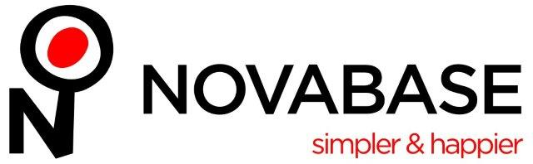
NOVABASE
AV. D. JOÃO II, 34
1998-031 LISBOA
PORTUGAL

MR. MÁRIO FIGUEIRA
EXECUTIVE DIRECTOR
E-mail: mario.figueira@novabase.pt
www.novabase.pt

Novabase is a multinational IT market leader in Portugal, listed on Euronext Lisbon since July 2000 and is a reference partner for the main IT players, with lasting joint ventures with major clients.
Novabase has head offices in Lisbon, Portugal, and offices in Spain (Madrid), United Kingdom (London), United Arab Emirates (Dubai), Angola (Luanda) and Mozambique (Maputo) and has developed projects in 38 countries on 4 continents.
In the Benelux market has a representation office in Brussels to support the projects in the European Institutions and private customers.

Novabase’s vision is to make life simpler and happier for people and businesses, through technology. Engineering and management combine with human sciences and design to create solutions focused on people.

Novabase works in:
Energy, Financial Services, Government, Telecommunications and Transports industries. Its current businesses are Celfocus, Financial Services Industry Business Solutions, Government, Transports and Energy Business Solutions, Infrastructures and Managed Services, IT Contracting and Venture Capital.

OPENSOFT
EDIFÍCIO AMOREIRAS SQUARE
RUA JOSHUA BENOLIEL 1, 3º D
1250-273 LISBOA
PORTUGAL

MS. JOANA PEIXOTO
COMMERCIAL AND MARKETING DIRECTOR
E-mail: joana.peixoto@opensoft.pt
www.opensoft.pt

Opensoft is a Portuguese company specialised in the development of technological solutions, tailored to client’s needs. This company has an experienced team of highly qualified engineers: constant training and skills upgrading is the way for innovation. Opensoft works with some national reference customers, whether in public administration or in the private sector.
Web environment: transfer, processing and validation of large volumes of data in environments with large numbers of simultaneous users, or involving complex validations.
Tailor made Software Development | Extensive experience developing customized solutions, mainly in web environment.
Portals | Security, confidentiality and authentication; High number of users.
Web applications | Data collecting, processing, validating and cross-checking (forms, statements, applications) ; Integration of services and systems (webservices).
Mobile Applications {iOS and Android} | Focus on accessibility and user experience and Management and marketing solutions.

Examples of services provided to the final customer:
SIMN - Integrated Notarial Methods : Software for Notary management. Ensures the daily management of the Notarial activity, through dematerialisation and automation of procedures.
Weventual : A service built to ease the event registration process and its appropriate payment. Allows the organizer to manage and monitor, at any time, the situation of entries and corresponding revenue.

PROLOGICA SGPS, SA
RUA DAS QUINTINHAS, 1- CARNAXIDE
2790-145 LISBOA
PORTUGAL

MR. DAVID BERNABÉ FERNANDES
EXECUTIVE DIRECTOR
E-mail: david.fernandes@prologica.pt
www.prologica.pt

Prológica was founded in 1984 and is one of the main players in the information technologies (IT) market, with solid references embodied in successful projects, both in the Public Sector and in the private market.
Prológica is ISO 9001 certified since December 1999. The scope of this certificate covers the activities of design, production, installation and after sales service.
In August 2013, Prológica and CPC-IS, two of the biggest and most representative Portuguese companies of the information technology sector, have decided to join forces to meet the challenges of the new world of IT: ITEN Solutions was created to respond to these challenges and help organizations simplifying the way they acquire, implement, manage and renew their Information Technology.​

Prológica Group comprises a series of Companies that focus their activity on Education, Healthcare, IT Systems Integrations and Real Estate.

EDUCATION

﻿Prológica has a strong focus on Education through Bridge | Linking Knowledge - Its Brand for Learning Technologies.

HEALTHCARE

Prológica also provides Healthcare services through its Company -Mhii - Technologies for Healthcare.​​

IT SERVICES
Through another Company of Prológica Group - ITEN Solutions - we are able to deliver end-end IT Services

REAL ESTATE
Prológica is present in the Real Estate Market since 2010, selling and renting properties.

QUIDGEST S.A.
RUA CASTILHO 63 – 6 ANDAR
1250-068 LISBOA
PORTUGAL

MS. ANNABELLE LE ROHELLEC
INTERNATIONAL BUSINESS DIRECTOR
E-mail: alerohellec@quidgest.com
www.quidgest.com

Quidgest is a consultancy and software engineering company, with headquarters in Lisbon, Portugal, implementing a disruptive strategy for the IT sector, based on the creation and improvement of automatic code generation processes. Genio, Quidgest´s platform for automatic code generation, enables deployment in a wide range of platforms (such as server, cloud, desktop, and mobile) and seamlessly integrates with a range of existing technologies.
Over the last 26 years, Genio has been used to generate hundreds of tailor-made solutions for organizations in both public and private sector across the globe.
Quidgest works in straight collaboration with Public Institutions in Europe, Asia, Africa and South-America.

TAGS

Financial

Health & Sports

Human Resources

Information Management

Procurement, Logistic & AssetsSolutions

Strategic Management

Unique Software Solutions

WP Examples

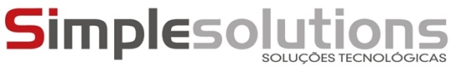
SIMPLE SOLUTIONS
TAGUSPARK – NÚCLEO CENTRAL, 204
2740-122 OEIRAS
PORTUGAL

MR. CARLOS TEIXEIRA
CEO
E-mail: c.teixeira@simplesolutions.pt
www.simplesolutions.pt

Simple Solutions is a technology company with 15 years of accumulated experience through multiple high value projects in various sectors, with particular focus on health.
SECTORS
Health
Education
Retail
Engineering
Industry
Government

- Development in Microsoft Technologies, Open Systems, Web and Mobile

- Proven experience on SharePoint platform

- Outsourcing to major national companies

- Activities in the markets of Portugal, Spain, Switzerland and Brazil

SOFTMORPHIS, LDA
AV. 5 DE OUTUBRO 146, 9º
1050-061 LISBOA
PORTUGAL

MR. COLM FOX
SALES TEAM
E-mail: colm.fox@morphis-tech.com
www.morphis-tech.com

In 1995, a team of young graduates, led by our founder and CEO Luis Andrade, began developing software with a mission: create the best legacy modernization tools in the world. This 20-year technology legacy morphed into a new company two years ago.

Morphis quickly gained the attention of major partners such as Microsoft, IBM, Oracle, Fujitsu and Cap Gemini, and clients including major banks, insurance and healthcare companies, telcos and software vendors, defense contractors and governments, and other major institutions.

Morphis is a software company with a proven value that derives from high specialization and expertise in modernization technologies, guiding in the process of revamping applications, analyzing, optimizing and modernizing them. Provides solutions as well as a comprehensive set of services for companies and organizations that wish to update their software applications or improve their development process and software infrastructure.

Products

certificator | transformer | docmine | frames | foundations | analytics

Morphis operates in the U.K., Spain, Brazil and in the United States of America.

TRUEWIND
AV. D. JOÃO II, 50 – 3º
1990-095 LISBOA
PORTUGAL

MR. JOÃO CAMPOS
DIRECTOR
E-mail: joao.campos@truewind.pt
www.truewind.pt

Truewind is an IT consultancy applying technology to create multi-channel engagement solutions for customers and employees, targeting businesses that want digital transformation but feel dragged down by the weight of changing existing processes and software.
Truewind delivers these solutions in weeks rather than months using the Outsystems rapid application delivery technology, achieving measurable results and changing the way customers relate to brands.
Truewind is a Premium Outsystems partner and has developed tens of IT projects using this technology.

SERVICES

Information systems are a key part to any business, essential to achieve better results, boost processes and streamline costs. These factors drive productivity and can be maximized by combining and reengineering processes with successful implementation of software solutions. Smartphones and tablets are everywhere and so can be the systems and processes, boosting adoption with mobility and bridging the physical to the virtual world.
Truewind reengineers processes by creating and operating the software solutions that enable them. Linking new solutions with existing systems, Truewind is able to leverage installed investments with new ones, in modern architectures and with new and easy to use interfaces. Truewind's goal is to support the Client in the transition from regarding software as a mandatory cost to regarding it as an asset that unlocks business information and interactions that should be fully explored.

