FAIR |  | DATE | PLACE | SECTOR | CONTACT
Expocomer |  | 9-12 March | Atlapa Convention Center,  Panama City, Panama | Multisectorial | Panacamara  +507 207 3433  +507 207 3434  expocomer@panacamara.org  www.expologistica.org
Feria Internacional de David 2016 | 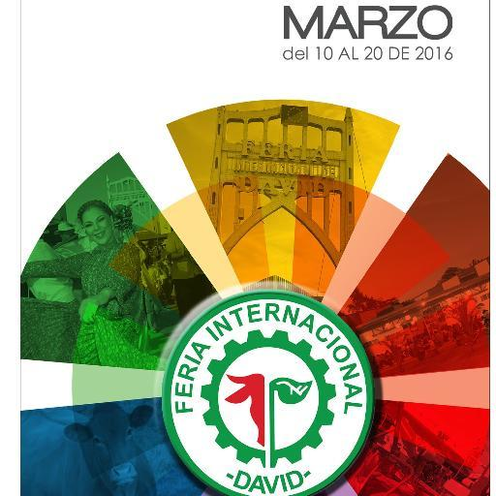 | 10-20 March | Feria Internacional de David,  Urbanización Lassonde,  David Chiriquí,  Rep. de Panamá | Multisectorial:  Agriculture  Artisans  Cultural  Commerce  Folklore | FIDA  Tel: +507 775 2128  Fax: +507 775 5428  ventas @ feriadedavid.com  www.feriadedavid.com
Expo Bebida 2016 |  | 1-3 April | Atlapa Convention Center,  Panama City, Panama | Beverages | Expo Quest  Tel: +507 388.4390 / 388.4359  expobebida.adm@gmail.com www.expobebidapty.com
Expo Vivienda 2016 |  | 14-17 April | Atlapa Convention Center,  Panama City, Panama | Real Estate | Cámara Panameña de la Construcción (CAPAC)  +507 265 2500  +507 265 2571  ferias@capac.org  www.viviendaverano.com
Expo Turismo Internacional 2016 |  | 27-28 May | Atlapa Convention Center,  Panama City, Panama | Tourism | Panacamara  Tel: +507 207 3433  Fax: +507 207 3434  expoturismo@panacamara.org  www.expotur.org
Expo Invest |  | 9-11 June | Atlapa Convention Center,  Panama City, Panama | Multisectorial | Expo Invest  +507 260 7977  info@expoinvestpanama.com  www.expoinvestpanama.com
InterLumi Panamá |  | 6-8 July | Atlapa Convention Center,  Panama City, Panama | Lighting Industry | America Expo Group  +507 236 3699  +507 236 3689  info@america-expo.com  www.inter-lumi.com
Expo Chiriquí 2016 |  | August TBD | Feria Internacional de David,  Urbanización Lassonde,  David Chiriquí, Rep. de Panamá | Real Estate | Cámara Panameña de la Construcción (CAPAC)  +507 265 2500  +507 265 2571  ferias@capac.org  www.capacexpo.com
Feria Internacional del Libro 2016 |  | 16-21 August | Atlapa Convention Center,  Panama City, Panama | Books  Media  Education  Literature  Communication | CAPALI  +507 390 4738  +507 390 4739  ferias@capac.org  www.capacexpo.com
Panamá Gastronómica  2016 | 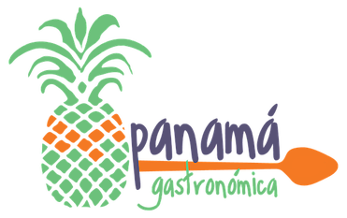 | 26-28 August | Atlapa Convention Center,  Panama City, Panama | Food  Wine  Craft Beers  Hotel and Restaurant Equipment  Chef Congress  Culinary Competition | Panamá Gastronómica  +507 270 0572  info@panamagastronomica.com  www.panamagastronomica.com
Expo Habitat 2016 | 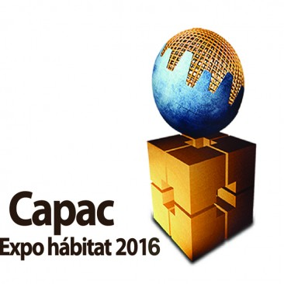 | 7-11 September | Atlapa Convention Center,  Panama City, Panama | Construction  Architecture  Machinery  Real Estate | Cámara Panameña de la Construcción (CAPAC)  +507 265 2500  +507 265 2571  ferias@capac.org  www.capacexpo.com
Expo Decoración y Diseño 2016 |  | 15-18 September | Atlapa Convention Center,  Panama City, Panama | Graphic Industry  Advertising | Panamá Expo Gráfica  Tel: +507 214 9383  expodecoracion@gmail.com  www.expodecoracionydiseno.com
Expo Mueble 2016 |  | 22-24 September | Atlapa Convention Center,  Panama City, Panama | Furniture | Panacamara  Tel: +507 207 3433  Fax: +507 207 3434  expomueble@panacamara.org  www.expomueble.org
Expomédica 2016 |  | 24-26 September | Atlapa Convention Center,  Panama City, Panama | Health  Wellness  Nutrition  Sports  Beauty | Panacamara  Tel: +507 207 3433  Fax: +507 207 3434  expomedica@panacamara.org  www.expomedica.org
Mercedes-Benz Fashion Week |  | October TBD | Atlapa Convention Center,  Panama City, Panama | Fashion | Physical Modelos  Tel: +507 207 3433  Fax: +507 207 3434  marieclaire@physicalmodelos.com.pa www.expotur.org
Expo Logística 2016 |  | 19-21 October | Atlapa Convention Center,  Panama City, Panama | Logistics  Transport | Panacamara  Tel: +507 207 3433  Fax: +507 207 3434  expologistica@panacamara.org  www.expologistica.org
Expo Bizfit 2016 |  | October TBD | Atlapa Convention Center,  Panama City, Panama | Innovation  Technology  Buisness | Panacamara/Capatec/City of Knowledge  Tel: +507 207 3433  Fax: +507 207 3434  bizfit@panacamara.org  www.bizfitpanama.com

